Test Plan

Billing Code: 7002888
Submitted by: Joe Truong
Submit Date: Sept. 17, 2007
Site: Disney Visa
URL: http://disney.go.com/visa/disneyland50th/

Test Case 1:

Go to http://disney.go.com/visa/disneyland50th/,

The link for Footnote # 15 – Pricing and Terms has been updated.

- click on Pricing and Terms near the bottom of the page:

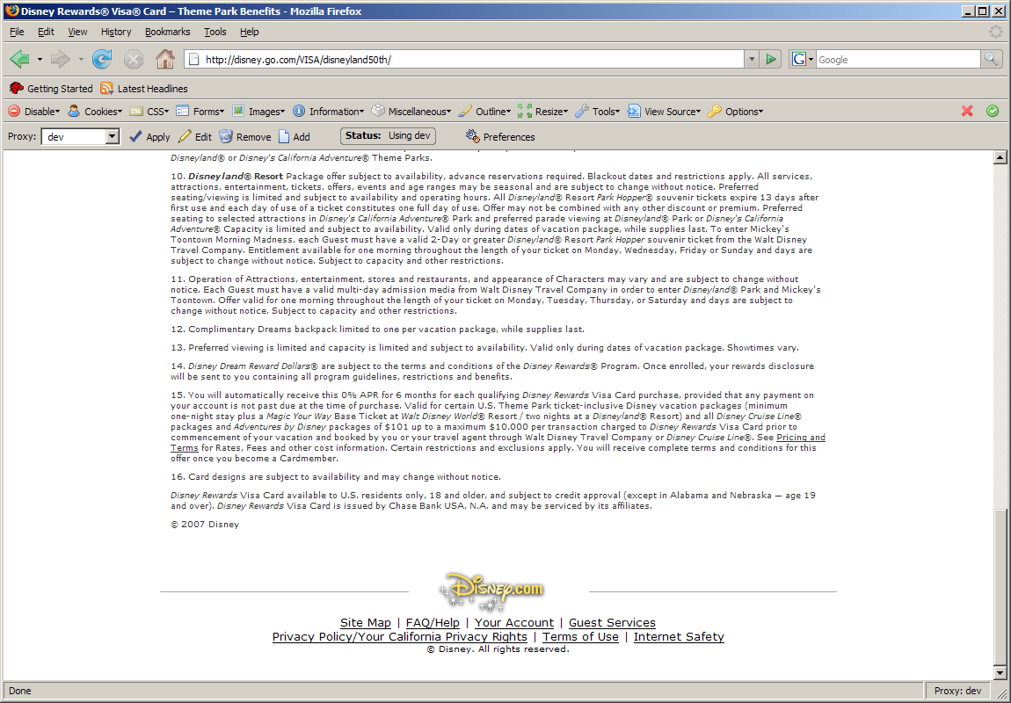

- Click on “continue”:

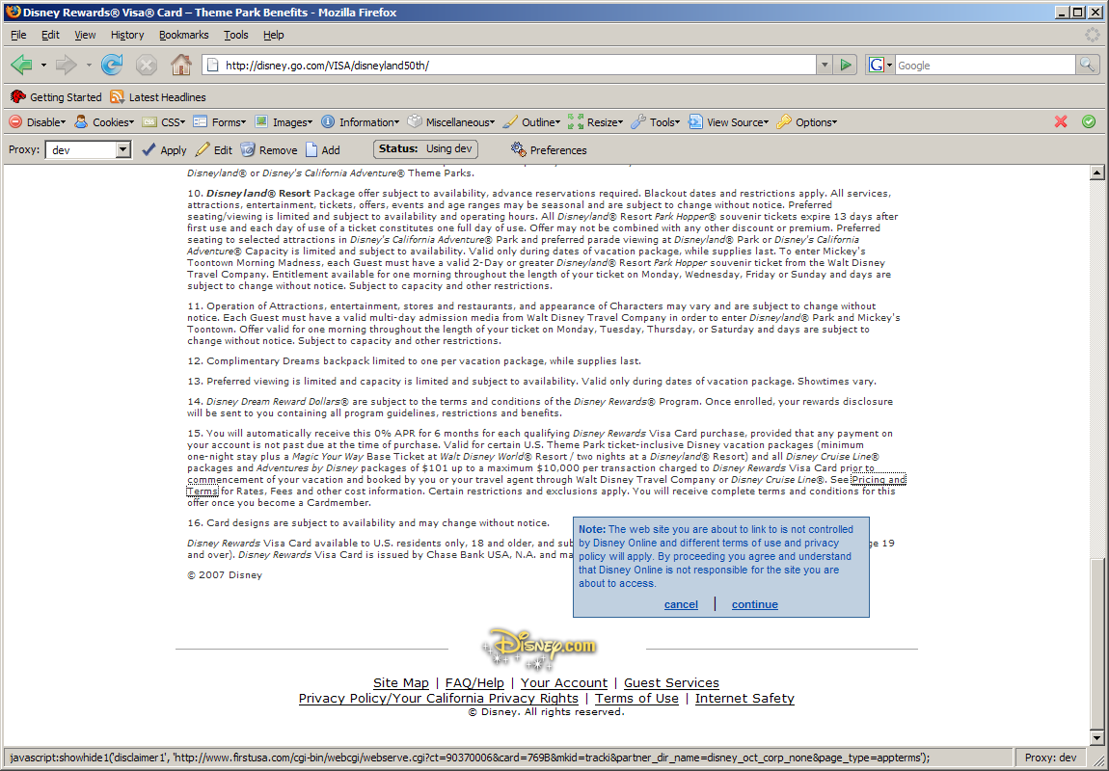

You are directed to the below page ( http://www.firstusa.com/cgi-bin/webcgi/webserve.cgi?pdn=pt_disney&card=B4WV&page_type=appterms ) :

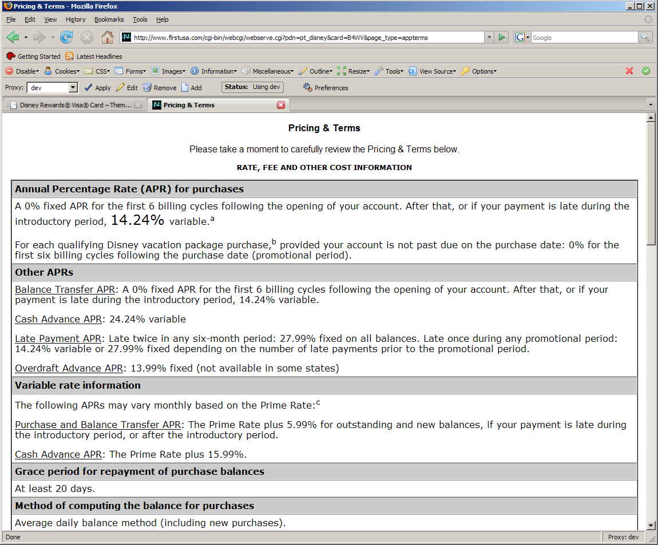

Testplan ends.

