Test Plan

Billing Code: 7002888
Submitted by: Joe Truong
Submit Date: Sept. 11, 2007
Site: Disney Visa
URL: http://disney.go.com/visa/disneyland50th/

Test Case 1:

Go to http://disney.go.com/visa/disneyland50th/,

Flash file has been updated:
- rollover copies for the following have been updated:

- Addition text added for “Exclusive Cardmember Vacation Package at the Disneyland Resort”… text:

“-Downtown Disney District Fun Card – special values for shopping, dining, and entertainment experiences(one per package)
-Dream Coin – sprinkled within pixie dust, these coins are rumored to make your Disney dreams come true”
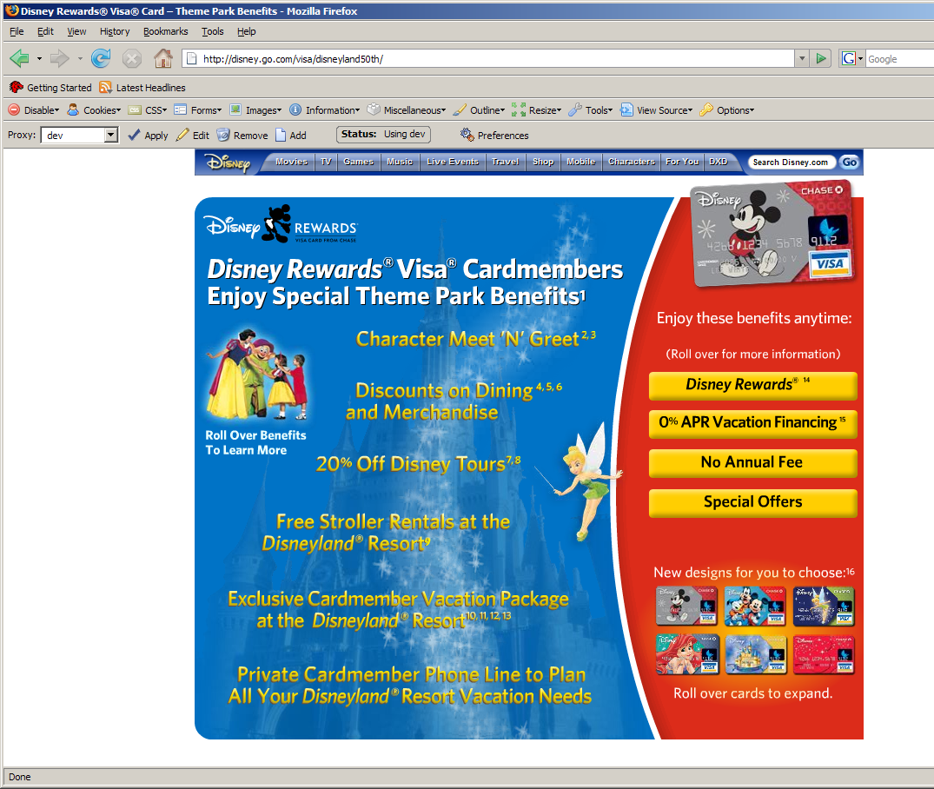

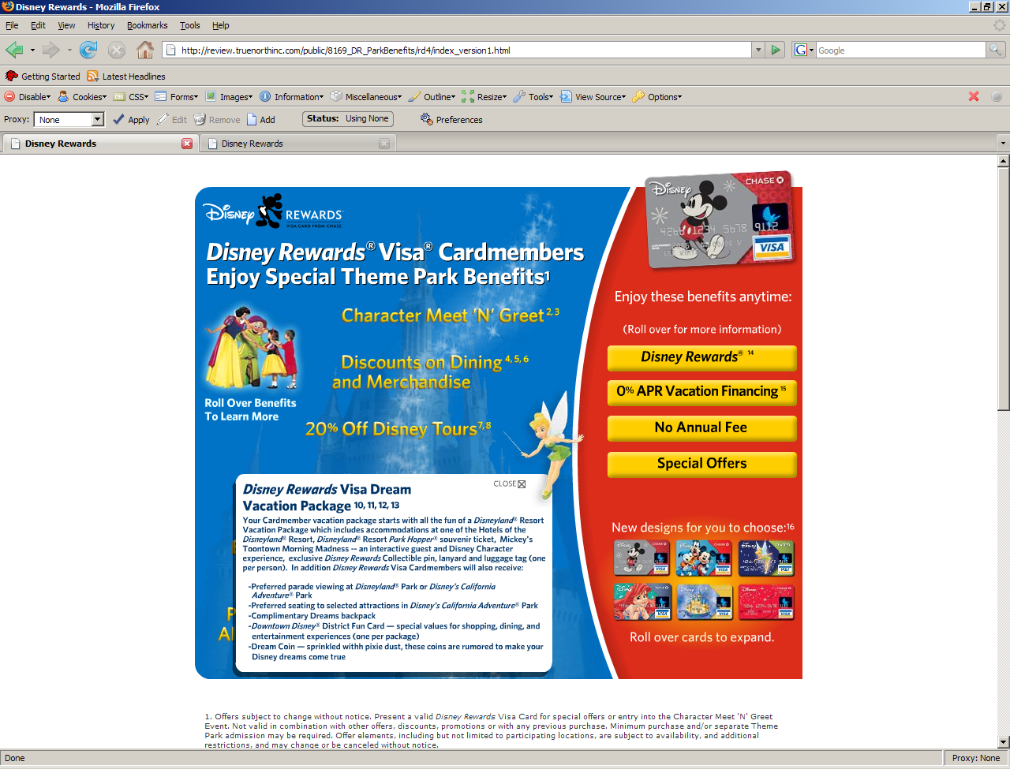

Testplan ends.

