Test Plan

Billing Code: 7002888
Submitted by: Joe Truong
Submit Date: August 8, 2007
Site: Disney Visa
URL: http://disney.go.com/visa/disneyland50th/

Test Case 1:

Go to http://disney.go.com/visa/disneyland50th/,

Flash file has been updated:
- rollover copies for the following have been updated:
- footnotes updated and footnote number 16 added

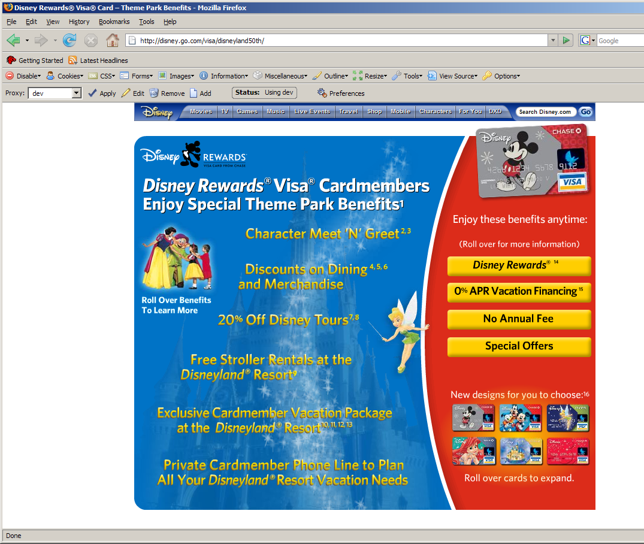

Test Case 2:

The following are updated footnotes that should appear on page:

1. Offers subject to change without notice. Present a valid Disney Rewards Visa Card for special offers or entry into the Character Meet 'N' Greet Event. Not valid in combination with other offers, discounts, promotions or with any previous purchase. Minimum purchase and/or separate Theme Park admission may be required. Offer elements, including but not limited to participating locations, are subject to availability, additional restrictions, and may change or be canceled without notice.
2. The Disneyland® Resort Character Meet 'N' Greet Event is offered once daily at a selected time at Disney's California Adventure® Park. Separate Theme Park admission required. Must present a valid Disney Rewards Visa Card for entry for up to 6 people per card. Operating time, days of the week, location and appearance of Characters may vary and are subject to change without notice. Subject to availability and location capacity. Offer includes one complimentary 5X7 Disney Friends Portrait per valid Cardmember account.
3. The Walt Disney World® Resort Character Meet 'N' Greet Event is offered once daily at a selected time at Epcot®. Separate Theme Park admission required. Must present a valid Disney Rewards Visa Card for entry for up to 6 people per card. Operating times, days of week, locations and appearance of Characters may vary and are subject to change without notice. Subject to availability and location capacity. Offer includes one complimentary 5 x 7 photo per valid Cardmember account.
4. At the Disneyland® Resort, dining offer excludes alcoholic beverages, merchandise, tax and gratuity. Discount valid at the following restaurant locations: in Disneyland® Park: Rancho del Zocalo, Carnation Cafe and Redd Rockett's Pizza Port; in Disney's California Adventure® Park: Pizza Oom Mow Mow, Wine Country Trattoria and The Vineyard Room; at Disneyland® Resort Hotels: Steakhouse 55 (from 6:00pm - 10pm only), Yamabuki and Disney's PCH Grill. Subject to restaurant operating hours and restaurant closures. Restaurant seating is subject to availability.
5. At the Disneyland® Resort, offer is valid only at select Disneyland® Resort stores and pin cart locations. A $50 minimum pre-tax single transaction purchase is required to receive discount. Not valid on previous purchases. Discount is not valid on purchases of DVD, VHS, software media, Walt Disney Classics Collections, Walt Disney Art Classics, original or limited-edition artwork, selected collectibles, food or beverage, Disney Dollars, Gift Cards, Ticket Media, Park Admission, Arcades, shipping or taxes. Discount does not apply at the following locations: Midway games, Fairytale Arts, Jewel of Orleans, Silhouette Studio, Portrait Artists, Parasol Cart, Heraldry Shop, Crystal Shops (Crystal Arts & Crystal d'Orleans), Face Painting, or at any Downtown Disney® District location other than World of Disney® Store, Marceline's Confectionery, and Disney's Pin Traders. May not be combined with any other discount, offer or promotion.
6. At Walt Disney World® Resort, a $50 minimum pre-tax single transaction purchase is required to receive discount. Discount is not valid on purchases of ticket media, gift certificates, Disney gift cards, videos, DVDs, Disney Dollars, sundries, periodicals, film, Lladro, Armani, Hummel, Swarovski Crystal, Walt Disney Classics Collection, other collectibles and select merchandise. May not be combined with any other discount, offer or promotion. Not valid on previous purchases.
7. At the Disneyland® Resort, receive 20% off the non-discounted price of select tours when you present your valid Disney Rewards Visa Card at time of purchase. Most tours require separate Theme Park admission. Cardmember must participate in the tour. Tours can be booked for up to 10 total guests. Some tours have age and other restrictions. May not be combined with any other discounts, offers or promotions. Subject to availability. Offer is subject to change without notice and may be subject to additional terms and conditions. Offer valid for "Welcome to Disneyland," "A Walk in Walt's Footsteps," and "Discover the Magic" tours. Advance reservations recommended and may be made up to 30 days prior to arrival by calling (714) 781-4400 or at the Guided Tour Welcome Center at Disneyland® Park. Tour tickets may not be sold or transferred for a commercial purpose.
8. At the Walt Disney World® Theme Parks, receive 20% off the non-discounted price of select tours when you present your valid Disney Rewards Visa Card at time of purchase. Most tours require separate theme park admission. Cardmember must participate in the tour. Tours can be booked for up to 10 total guests. Some tours have age and other restrictions. May not be combined with any other discounts, offers or promotions. Subject to availability. Offer is subject to change without notice and may be subject to additional terms and conditions. Discounts are not available on the following tours: VIP tours, programs exclusive to groups (Disney by Design, Innovations in Action; Inspiration: Through Walt's Eyes), group team building programs (Making The News, Pluto's Pursuit, RadioActivity).
9. Offer is subject to availability while supplies last. Must present a valid Disney Rewards Visa Card. Stroller availability varies based on theme park attendance and other factors. Limit two free strollers per cardmember per day. Available only at the Main Entrance Stroller Rental Locations in Disneyland® or Disney's California Adventure® Theme Parks.
10. Disneyland® Resort Package offer subject to availability, advance reservations required. Blackout dates and restrictions apply. All services, attractions, entertainment, tickets, offers, events and age ranges may be seasonal and are subject to change without notice. Preferred seating/viewing is limited and subject to availability and operating hours. All Disneyland® Resort Park Hopper® souvenir tickets expire 13 days after first use and each day of use of a ticket constitutes one full day of use. Offer may not be combined with any other discount or premium. Preferred seating to selected attractions in Disney's California Adventure® Park and preferred parade viewing at Disneyland® Park or Disney's California Adventure® Park capacity is limited and subject to availability. Valid only during dates of vacation package, while supplies last. Mickey's Toontown Morning Madness does not operate daily and is subject to capacity and other restrictions. Operation of attractions, entertainment stores and restaurants, appearances of characters, and days of operation may vary and are subject to change without notice.
11. Operation of Attractions, entertainment, stores and restaurants, and appearance of Characters may vary and are subject to change without notice. Each Guest must have a valid multi-day admission media from Walt Disney Travel Company in order to enter Disneyland® Park and Mickey's Toontown. Entitlement available for one morning throughout the length of your ticket on Monday, Tuesday, Thursday, or Saturday and days are subject to change without notice. Subject to capacity and other restrictions.
12. Complimentary Dreams backpack limited to one per vacation package, while supplies last.
13. Preferred viewing is limited and capacity is limited and subject to availability. Valid only during dates of vacation package. Showtimes vary.
14. Disney Dream Reward Dollars® are subject to the terms and conditions of the Disney Rewards® Program. Once enrolled, your rewards disclosure will be sent to you containing all program guidelines, restrictions and benefits.
15. You will automatically receive this 0% APR for 6 months for each qualifying Disney Rewards Visa Card purchase, provided that any payment on your account is not past due at the time of purchase. Valid for certain U.S. Theme Park ticket-inclusive Disney vacation packages (minimum one-night stay plus a Magic Your Way Base Ticket at Walt Disney World® Resort / two nights at a Disneyland® Resort) and all Disney Cruise Line® packages and Adventures by Disney packages of $101 up to a maximum $10,000 per transaction charged to Disney Rewards Visa Card prior to commencement of your vacation and booked by you or your travel agent through Walt Disney Travel Company or Disney Cruise Line®. See Pricing and Terms for Rates, Fees and other cost information. Certain restrictions and exclusions apply. You will receive complete terms and conditions for this offer once you become a Cardmember.
16. Card designs are subject to availability and may change without notice.
Disney Rewards Visa Card available to U.S. residents only, 18 and older, and subject to credit approval (except in Alabama and Nebraska — age 19 and over). Disney Rewards Visa Card is issued by Chase Bank USA, N.A. and may be serviced by its affiliates.
© 2007 Disney

Testplan ends.

