Test Plan

Billing Code: 7002049
Submitted by: Hubert Ventura x.3926
Submit Date: January 3, 2007
Site: Disney Visa
URL: http://disney.go.com/visa/disneyland50th/

Go to http://disney.go.com/visa/disneyland50th/, rollover copies for the following have been updated:

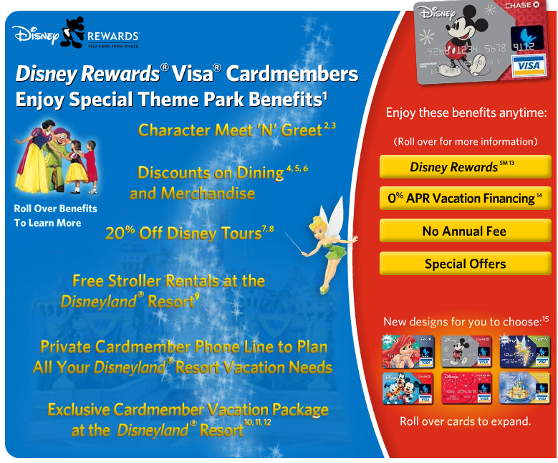

- look in #14, the a “disclaimer” was added to the “Pricing and Terms” link -- http://www.firstusa.com/cgi-bin/webcgi/webserve.cgi?ct=90370006&card=769B&mkid=tracki&partner_dir_name=disney_oct_corp_none&page_type=appterms

