Test Plan

URL: http://disney.go.com/visa/disneyland50th/

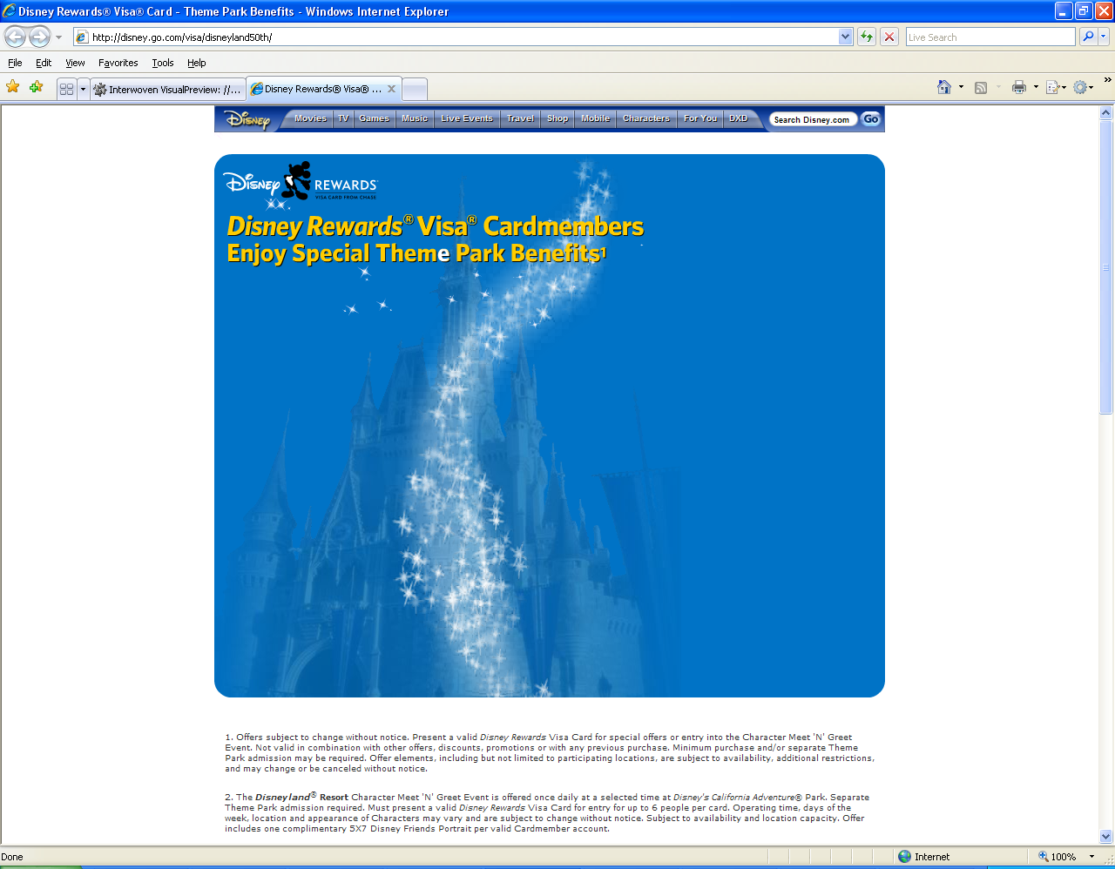
Here

Check: Flash is available

