Disney Legends

Contacts:
Senior Producer: Sean Carmody
Producer: Patrick Henry
Developer: Karianne Licon
Artist: Susie Kim

Programs Needed:
- Content Editor 4.5.1 – this can be downloaded at: http://wiki.corp.dig.com/bin/view/DOL/SPNGuestServicesGoPublish
  - Click on “Windows Installer – Content Editor Launcher”
  - Site name = SPN
  - Server URL for dev environment = http://dnhdiscms01:7916/cms
  - Server URL for live environment = http://espnpub01c:7916/cms
  - New users will need to be given access by an admin with a username and password
- HTML Editor – open tea files using: HomeSite, TextPad, or other
- Flash MX 2004 – open flash files

Useful Locations:
- Template location: \\dnhdiscms01\Templates\disney\utilbar\GPTeaAppSPN\site\legends
- TeaServlet location: http://dnhdisbar01:7916/system/teaservlet/Admin?subTemplate=system.teaservlet.AdminTemplates
  - You will use this applet to reload templates and check for template errors
- Dev Environment URL: http://dnhdisbar01:7916/legends/index
- Live Environment URL: http://legends.disney.go.com/legends/index
- Template drop spot for SI: \\tmplstg01.starwave.com\acpt_Templates\disney\utilbar\CMSTeaAppSPN\site\legends

Update Information:
This site is built using Dynamic Go Publish and is set up to not need scheduled updates. It randomly pulls in the features on the homepage. However, content can be scheduled in to each of the following components: Featured Legend, Quick Quote, and “Who is this legend?”.

Site is built with 2 sets of configuration templates for different ad types: 1.) rectangle (300x250) and 2.) Skyscrapers (160x600 or 120x600). The site can easily be switched between the 2 by logging in to Content Editor 4.5.1, go to the Legends > DLLayout > Disney Legends Layout, open this content type. You will see a layout field, if you click on that there is a drop down that lets you chose from the 2 ad configurations.

Site Breakdown:
Home page:
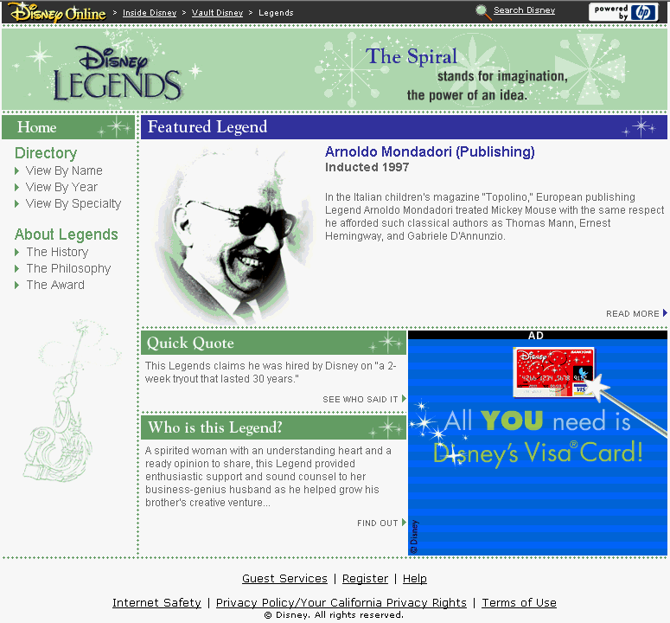

About Legends:
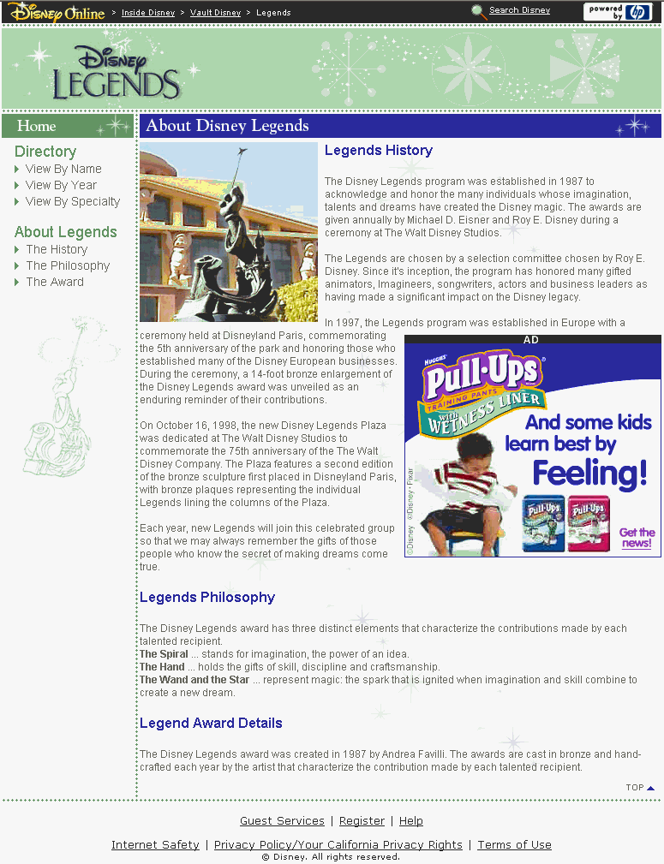

Detail Legends:
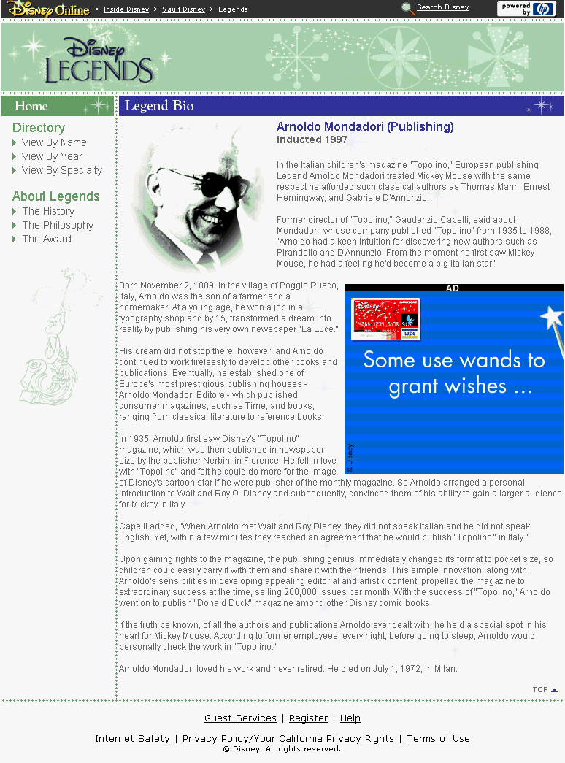
Directory Listing by Legend Name:
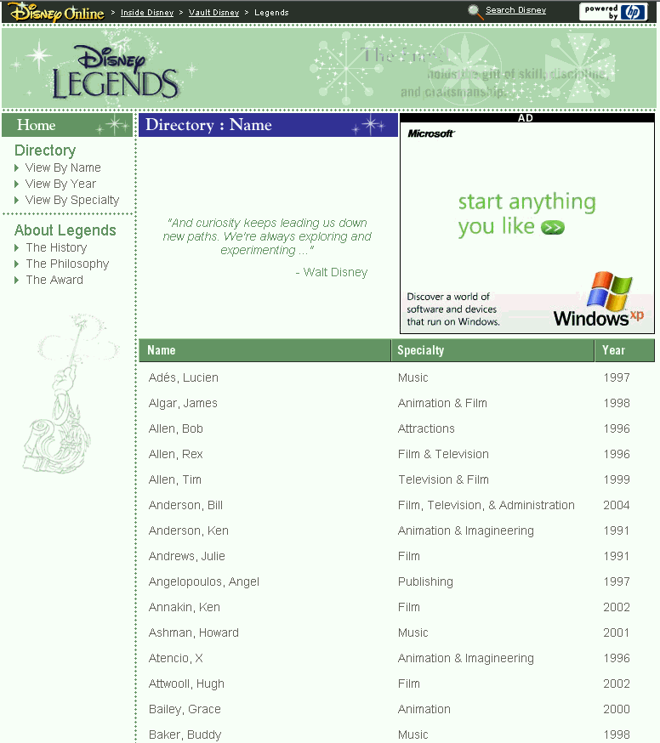
Directory Listing by Legend Specialty:
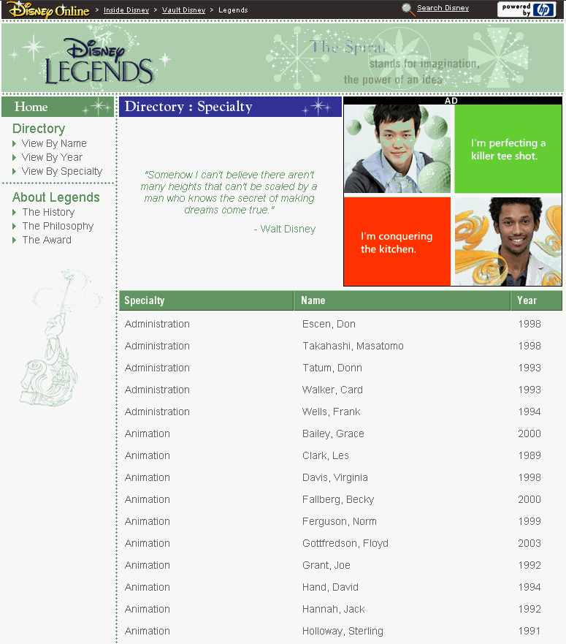
Directory Listing by Legend Year of Induction:
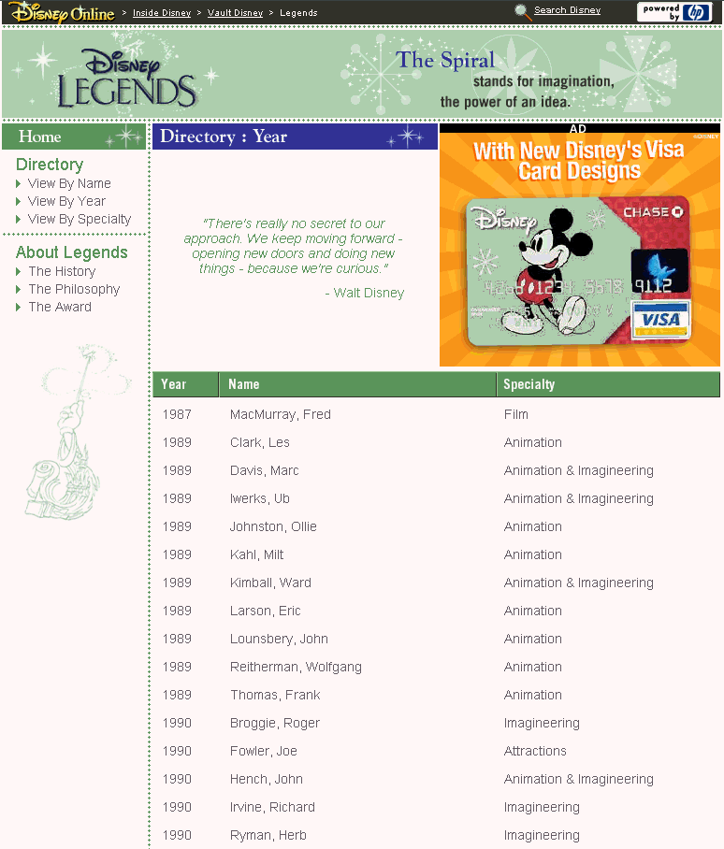
Test Plans:
All test plans are kept at the following location: \\neo\tspool\dev\disney\vault\WORKAREA\spn\ProjectAttachments.

Global Elements:
- Micro Chrome (Dark) - http://disney.go.com/globalmedia/chrome/chrome.js
- Breadcrumb - http://disney.go.com/vault/legends/images/breadcrumb.js
  - Inside Disney > Vault Disney > Legends
- Disney Legends Header (flash) - http://disney.go.com/vault/legends/images/legends_header.swf
  - Final Source: \\neo\tspool\dev\disney\vault\WORKAREA\spn\legends\images\_source\legends_header.fla
  - Final Asset Location: \\neo\tspool\dev\disney\vault\WORKAREA\spn\legends\images
  - Disney Legends Logo in movie is linkable back to home page
- Left Hand Navigation (Tea template)
  - Home – links to home page
  - View By Name - links to Directory page listing all legends by Name
  - View By Year - links to Directory page listing all legends by Year they were inducted
  - View By Specialty - links to Directory page listing all legends by their specialty
  - The History - links to About page
  - The Philosophy - links to About page anchored to Philosophy section
  - The Award - links to About page anchored to Award section
- Legal Footer (Tea template)

Templates: (\\dnhdiscms01\Templates\disney\utilbar\GPTeaAppSPN\site\legends\...)
- Main Template (index.tea) – main tea file that checks to see which layout design to use: rectangle or skyscraper and then pulls in rectangle.tea or skyscraper.tea.
- Rectangle Template (rectangle.tea) – legends home page using the rectangle layout
  - Global Template (global.tea) – global tea template that writes out the root path for URL’s and images, as well as global Hit Box variables.
  - Meta Tags
    - Description & Keywords are defined in content editor at Legends > DLLayout > Disney Legends Layout
    - Meta Tags (metatags.tea) – the rest of the meta tags are global tea template
  - Style Sheet (stylesheet.tea) – global tea template
  - Micro Chrome – calls javascript file http://disney.go.com/globalmedia/chrome/chrome.js.
  - Hit Box (hitbox.tea) – global tea template
  - Flash Header (header.tea) – global tea template that holds the flash header
  - Navigation (nav.tea) – global tea template that holds the left side navigation. Template writes out format depending on if it is passed the parameter rectangle or skyscraper.
  - Featured Legend (feature.tea) – global tea template that writes out the format for the “Featured Legend” section depending on if it is passed the parameter rectangle or skyscraper.
    - Pulls in legend Name, Specialty, Image, Bio Text, and Year Inducted. (all fields in content editor)
    - Template checks first to see if there is a legend already scheduled in content editor, if not it will pull a legend from a random list (getLegendForFeatured.tea and getRandomLegendKey.tea).
    - Calls template getBioBeforeTheFold.tea which cuts off Bio Text after 250 characters and adds “…” to the end of the text
  - Quick Quote (quote.tea) – global tea template that writes out the format for the “Quick Quote” section depending on if it is passed the parameter rectangle or skyscraper.
    - Pulls in legend quote from content editor
    - Template checks first to see if there is a legend quote already scheduled in content editor, if not it will pull a legend quote from a random list (getLegendForQuote.tea, getLegendForRandomQuote.tea, and getRandomLegendKey.tea).
  - Trivia (trivia.tea) – global tea template that writes out the format for the “Who is this Legend?” section depending on if it is passed the parameter rectangle or skyscraper.
    - Pulls in legend fact/trivia from content editor
    - Template checks first to see if there is a fact already scheduled in content editor, if not it will pull a fact from a random list (getLegendForTrivia.tea and getRandomLegendKey.tea).
  - Ad (ad.tea) – global tea template that writes out which ad tag to use depending on if it is passed the parameter “MediumRectangle” or “Vertical”.
  - Legal Footer – calls javascript file http://disney.go.com/globalmedia/legal_footer/legalfooter.js
- Skyscraper Template (skyscraper.tea) – legends home page using the skyscraper layout
  - Global Template (global.tea) – global tea template that writes out the root path for URL’s and images, as well as global Hit Box variables.
  - Meta Tags
    - Description & Keywords are defined in content editor at Legends > DLLayout > Disney Legends Layout
    - Meta Tags (metatags.tea) – the rest of the meta tags are global tea template
  - Style Sheet (stylesheet.tea) – global tea template
  - Micro Chrome – calls javascript file http://disney.go.com/globalmedia/chrome/chrome.js.
  - Hit Box (hitbox.tea) – global tea template
  - Flash Header (header.tea) – global tea template that holds the flash header
  - Navigation (nav.tea) – global tea template that holds the left side navigation. Template writes out format depending on if it is passed the parameter rectangle or skyscraper.
  - Featured Legend (feature.tea) – global tea template that writes out the format for the “Featured Legend” section depending on if it is passed the parameter rectangle or skyscraper.
    - Pulls in legend Name, Specialty, Image, Bio Text, and Year Inducted. (all fields in content editor)
    - Template checks first to see if there is a legend already scheduled in content editor, if not it will pull a legend from a random list (getLegendForFeatured.tea and getRandomLegendKey.tea).
    - Calls template getBioBeforeTheFold.tea which cuts off Bio Text after 250 characters and adds “…” to the end of the text
  - Quick Quote (quote.tea) – global tea template that writes out the format for the “Quick Quote” section depending on if it is passed the parameter rectangle or skyscraper.
    - Pulls in legend quote from content editor
    - Template checks first to see if there is a legend quote already scheduled in content editor, if not it will pull a legend quote from a random list (getLegendForQuote.tea, getLegendForRandomQuote.tea, and getRandomLegendKey.tea).
  - Trivia (trivia.tea) – global tea template that writes out the format for the “Who is this Legend?” section depending on if it is passed the parameter rectangle or skyscraper.
    - Pulls in legend fact/trivia from content editor
    - Template checks first to see if there is a fact already scheduled in content editor, if not it will pull a fact from a random list (getLegendForTrivia.tea and getRandomLegendKey.tea).
  - Ad (ad.tea) – global tea template that writes out which ad tag to use depending on if it is passed the parameter “MediumRectangle” or “Vertical”.
  - Legal Footer – calls javascript file http://disney.go.com/globalmedia/legal_footer/legalfooter.js
- About Legends Templates
  - About Legends Rectangle layout (about.tea) – template for about page with the rectangle ad
    - Global Template (global.tea) – global tea template that writes out the root path for URL’s and images, as well as global Hit Box variables.
    - Meta Tags
      - Title, Description, & Keywords are defined in content editor at Legends > DLPage > About Disney Legends
      - Meta Tags (metatags.tea) – the rest of the meta tags are global tea template
    - Style Sheet (stylesheet.tea) – global tea template
    - Micro Chrome – calls javascript file http://disney.go.com/globalmedia/chrome/chrome.js.
    - Hit Box (hitbox.tea) – global tea template
    - Flash Header (header.tea) – global tea template that holds the flash header
    - Navigation (nav.tea) – global tea template that holds the left side navigation. Template writes out format depending on if it is passed the parameter rectangle or skyscraper.
    - Ad (ad.tea) – code checks to see if user is on Mac IE, if true than they don’t get an ad. Otherwise, global tea template writes out the ad tag for the parameter “MediumRectangle”
    - Text – pulls in the About Legends titles and paragraphs from content editor.
    - Legal Footer – calls javascript file http://disney.go.com/globalmedia/legal_footer/legalfooter.js
  - About Legends Skyscraper layout (about2.tea) – template for about page with the skyscraper ad
    - Global Template (global.tea) – global tea template that writes out the root path for URL’s and images, as well as global Hit Box variables.
    - Meta Tags
      - Title, Description, & Keywords are defined in content editor at Legends > DLPage > About Disney Legends
      - Meta Tags (metatags.tea) – the rest of the meta tags are global tea template
    - Style Sheet (stylesheet.tea) – global tea template
    - Micro Chrome – calls javascript file http://disney.go.com/globalmedia/chrome/chrome.js.
    - Hit Box (hitbox.tea) – global tea template
    - Flash Header (header.tea) – global tea template that holds the flash header
    - Navigation (nav.tea) – global tea template that holds the left side navigation. Template writes out format depending on if it is passed the parameter rectangle or skyscraper.
    - Ad (ad.tea) – code checks to see if user is on Mac IE, if true than they don’t get an ad. Otherwise, global tea template writes out the ad tag for the parameter “Vertical”
    - Main Text – pulls in the About Legends titles and paragraphs from content editor.
    - Legal Footer – calls javascript file http://disney.go.com/globalmedia/legal_footer/legalfooter.js
- Detail Templates
  - Detail Legends Rectangle Layout (detail.tea) – template for the detail legends pages with the rectangle ad
    - Global Template (global.tea) – global tea template that writes out the root path for URL’s and images, as well as global Hit Box variables.
    - Meta Tags
      - Title, Description, & Keywords are defined in content editor at Legends > DLPage > About Disney Legends
    - Meta Tags (metatags.tea) – the rest of the meta tags are global tea template
    - Style Sheet (stylesheet.tea) – global tea template
    - Micro Chrome – calls javascript file http://disney.go.com/globalmedia/chrome/chrome.js.
    - Hit Box (hitbox.tea) – global tea template
    - Flash Header (header.tea) – global tea template that holds the flash header
    - Navigation (nav.tea) – global tea template that holds the left side navigation. Template writes out format depending on if it is passed the parameter rectangle or skyscraper.
    - Ad (ad.tea) – code checks to see if user is on Mac IE, if true than they don’t get an ad. Otherwise, global tea template writes out the ad tag for the parameter “MediumRectangle”
    - Main Text – pulls in the Legends Name, Specialty, Year Inducted, Biography Text, and image.
    - Legal Footer – calls javascript file http://disney.go.com/globalmedia/legal_footer/legalfooter.js
  - Detail Legends Skyscraper Layout (detail2.tea) – template for the detail legends pages with the skyscraper ad
    - Global Template (global.tea) – global tea template that writes out the root path for URL’s and images, as well as global Hit Box variables.
    - Meta Tags
      - Title, Description, & Keywords are defined in content editor at Legends > DLPage > About Disney Legends
    - Meta Tags (metatags.tea) – the rest of the meta tags are global tea template
    - Style Sheet (stylesheet.tea) – global tea template
    - Micro Chrome – calls javascript file http://disney.go.com/globalmedia/chrome/chrome.js.
    - Hit Box (hitbox.tea) – global tea template
    - Flash Header (header.tea) – global tea template that holds the flash header
    - Navigation (nav.tea) – global tea template that holds the left side navigation. Template writes out format depending on if it is passed the parameter rectangle or skyscraper.
    - Ad (ad.tea) – code checks to see if user is on Mac IE, if true than they don’t get an ad. Otherwise, global tea template writes out the ad tag for the parameter “Vertical”
    - Main Text – pulls in the Legends Name, Specialty, Year Inducted, Biography Text, and image.
    - Legal Footer – calls javascript file http://disney.go.com/globalmedia/legal_footer/legalfooter.js
- Directory Templates
  - Directory Listing Rectangle Layout (direct.tea) – template for the directory listing by Name, Specialty, or Year Inducted with the rectangle ad
    - Global Template (global.tea) – global tea template that writes out the root path for URL’s and images, as well as global Hit Box variables.
    - Meta Tags
      - Title, Description, & Keywords are defined in content editor at Legends > DLPage > About Disney Legends
    - Meta Tags (metatags.tea) – the rest of the meta tags are global tea template
    - Style Sheet (stylesheet.tea) – global tea template
    - Micro Chrome – calls javascript file http://disney.go.com/globalmedia/chrome/chrome.js.
    - Hit Box (hitbox.tea) – global tea template
    - Flash Header (header.tea) – global tea template that holds the flash header
    - Navigation (nav.tea) – global tea template that holds the left side navigation. Template writes out format depending on if it is passed the parameter rectangle or skyscraper.
    - Main Text – lists out legends depending on which type was selected to sort it (name, specialty, or year inducted)
    - Ad (ad.tea) – global tea template that writes out which ad tag to use depending on if it is passed the parameter “MediumRectangle” or “Vertical”.
    - Legal Footer – calls javascript file http://disney.go.com/globalmedia/legal_footer/legalfooter.js
  - Directory Listing Skyscraper Layout (direct2.tea) - template for the directory listing by Name, Specialty, or Year Inducted with the skyscraper ad
    - Global Template (global.tea) – global tea template that writes out the root path for URL’s and images, as well as global Hit Box variables.
    - Meta Tags
      - Title, Description, & Keywords are defined in content editor at Legends > DLPage > About Disney Legends
    - Meta Tags (metatags.tea) – the rest of the meta tags are global tea template
    - Style Sheet (stylesheet.tea) – global tea template
    - Micro Chrome – calls javascript file http://disney.go.com/globalmedia/chrome/chrome.js.
    - Hit Box (hitbox.tea) – global tea template
    - Flash Header (header.tea) – global tea template that holds the flash header
    - Navigation (nav.tea) – global tea template that holds the left side navigation. Template writes out format depending on if it is passed the parameter rectangle or skyscraper.
    - Main Text – lists out legends depending on which type was selected to sort it (name, specialty, or year inducted)
    - Ad (ad.tea) – global tea template that writes out which ad tag to use depending on if it is passed the parameter “MediumRectangle” or “Vertical”.
    - Legal Footer – calls javascript file http://disney.go.com/globalmedia/legal_footer/legalfooter.js

Publishing:
- Making Template Changes
  - change templates
  - reload templates in dev using the TeaServlet (http://dnhdisbar01:7916/system/teaservlet/Admin?subTemplate=system.teaservlet.AdminTemplates)
  - test using the dev URL (http://dnhdisbar01:7916/legends/index)
  - QA test in dev as well
  - once approved by QA, move templates to the template drop at \\tmplstg01.starwave.com\acpt_Templates\disney\utilbar\CMSTeaAppSPN\site\legends
  - Fill out Roll Request form at: http://webops.online.disney.com/, click on request forms, then click on Roll templates on a template staging server (example or form filled out below)
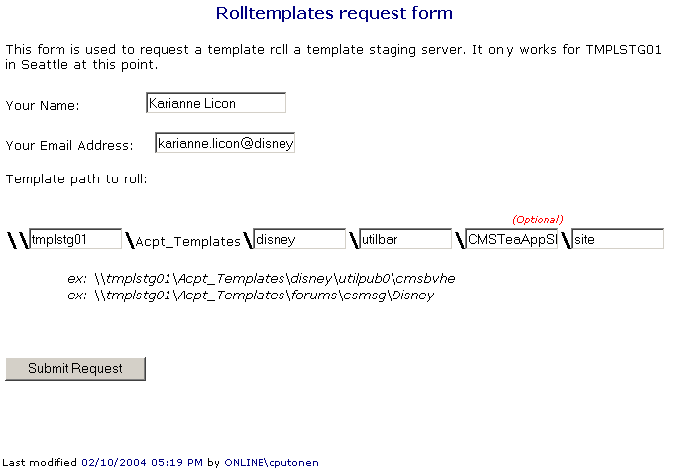
  - SI will send an e-mail once request has been completed
  - Test changes on live site at http://legends.disney.go.com/legends/index
- Making Content Changes (all content changes should be made to the live site version of the database)
  - Log-in to Content Editor using the live site path (http://espnpub01c:7916/cms)
  - Make content changes
  - Publish content to the live site (highlight content > right click > select publish to live site)

