

Archives Modified Redesign
Design & Production Notes

March 19, 2004
CONTENTS

OVERVIEW 3
PROJECT SUMMARY 3
SITE MAP 4
WIRE FRAMES 5
GLOBAL ELEMENTS 7
Production Information 9

OVERVIEW

Disney.com currently needs to boost quickly its 300x250 ad inventory. The top-level pages in the Disney Archives offer a comparatively easy place to make modifications that will result strong improvments to this inventory need.

PROJECT SUMMARY

Disney Archives is presently broken into the following five main top-level pages, each of which has a 468x60 ad:

- Movies (A-L): http://disney.go.com/vault/archives/movies_al.html
- Movies (M-Z): http://disney.go.com/vault/archives/movies_mz.html
- Characters (A-I): http://disney.go.com/vault/archives/characters_ai.html
- Characters (J-Z): http://disney.go.com/vault/archives/characters_jz.html
- Villains: http://disney.go.com/vault/archives/villains.html

This project will result in the following changes:

- Create a NEW homepage for the Archives with the following:
  - 300x250 ad unit.
  - Updateable feature spots for a: Movie, Character, Villain.
  - Navigational links to: Movies’ page, Characters’ page, Villains’ page, Dave Smith
- Movies Pages
  - Remove 468x60 ad
  - Move Disney Archives logo into the space formerly occupied by the ad
  - Go from two Movies pages (A-L, M-Z) to three Movies pages (A-I, J-Q, R-Z)
  - Build in space for a 300x250 ad
  - Should be a templated design that can be repeated for Characters and Villains.
- Characters Pages
  - Remove 468x60 ad
  - Move Disney Archives logo into the space formerly occupied by the ad
  - Go from two Characters pages (A-I, J-Z) to three Characters pages (A-I, J-Q, R-Z)
  - Build in space for a 300x250 ad
- Villains Page
  - Remove 468x60 ad
  - Move Disney Archives logo into the space formerly occupied by the ad
  - Go from one Villains pages to three Villains pages (A-I, J-Q, R-Z)
  - Build in space for a 300x250 ad

Please note that, as a result of these changes, the current site will go from having five top-level pages to 10 top-level pages.

SITE MAP

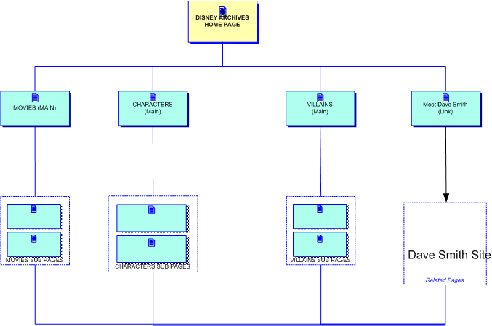

Wire Frames
Disney Archives Main Page

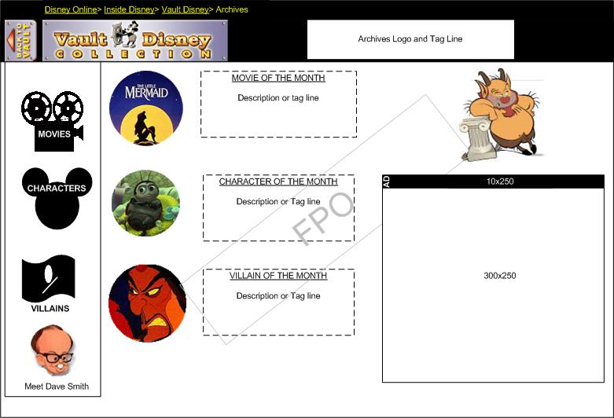
HTML Copy
HTML Copy
HTML Copy

Page Element Notes:

The above design is for guidance only. It need not be accepted as gospel.

- Page should be 770 wide
- Three feature areas with corresponding text placement.
- Iconically-driven lefthand nav (this is up to the art director)
- Phil should remain as the host
- 300x250 in lower right corner

Wire Frames
Disney Archives Top Level Nav Pages
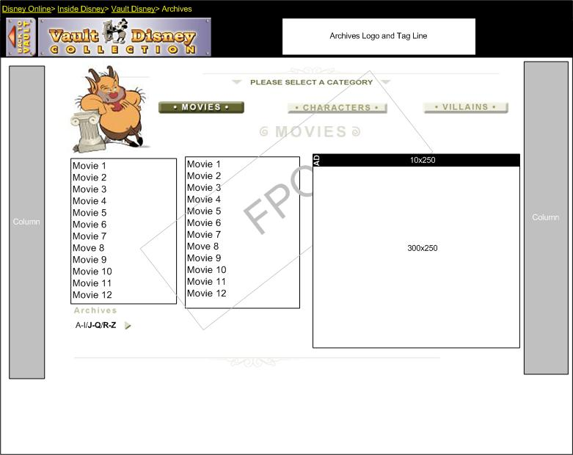
Dave Smith quote and link usually here. We will have to see if it can be acommodated to fit.

Page Element Notes:

The above design could be changed based on demands and challenges of the HTML table structure.

- Template should apply to all nine top-level nav pages—it will be re-created nine times.
- Page should be 770 wide
- Two content lists per page
- Phil should remain as the host
- 300x250 in lower right corner
- Dave Smith content usually sites under the bottom line. We will have to see if it can be accomodated to fit.

GLOBAL ELEMENTS

Chrome: Black
Breadcrumb: Inside Disney> Vault Disney>Archives
Metatags:

New Archives Homepage

- <TITLE>Disney Online--Disney Archives</TITLE>
<META NAME="DESCRIPTION" CONTENT="Disney Archives is the online of Disney’s rich character, movie, and villain history.">
<META NAME="KEYWORDS" CONTENT="disney, villains, characters, movies, history, histories,

Movies Pages
- <TITLE>Disney Online – Disney Archives – Movies Index A-I</TITLE>
<META NAME="DESCRIPTION" CONTENT="Dig into online archives to learn about the movies of Disney’s distant and not-so-distant past.">
<META NAME="KEYWORDS" CONTENT="disney, movies, trivia, history, characters, movie history, villains">

- <TITLE>Disney Online – Disney Archives – Movies Index J-Q</TITLE>
<META NAME="DESCRIPTION" CONTENT="Dig into online archives to learn about the movies of Disney’s distant and not-so-distant past.">
<META NAME="KEYWORDS" CONTENT="disney, movies, trivia, history, characters, movie history, villains">

- <TITLE>Disney Online – Disney Archives – Movies Index R-Z</TITLE>
<META NAME="DESCRIPTION" CONTENT="Dig into online archives to learn about the movies of Disney’s distant and not-so-distant past.">
<META NAME="KEYWORDS" CONTENT="disney, movies, trivia, history, characters, movie history, villains">

Character Pages
- <TITLE>Disney Online – Disney Archives – Characters Index A-I</TITLE>
<META NAME="DESCRIPTION" CONTENT="Visit the online Archives to read about famous and not-so-famous Disney characters.">
<META NAME="KEYWORDS" CONTENT="disney, characters, movies, trivia, history, movie history, villains">

- <TITLE>Disney Online – Disney Archives – Characters Index J-Q</TITLE>
<META NAME="DESCRIPTION" CONTENT=" Visit the online Archives to read about famous and not-so-famous Disney characters.">
<META NAME="KEYWORDS" CONTENT=" disney, characters, movies, trivia, history, movie history, villains ">

- <TITLE>Disney Online – Disney Archives – Movies Index R-Z</TITLE>
<META NAME="DESCRIPTION" CONTENT="Dig into online Archives to learn about the movies of Disney’s distant and not-so-distant past.">
<META NAME="KEYWORDS" CONTENT=" disney, characters, movies, trivia, history, movie history, villains ">

Villains Pages
- <TITLE>Disney Online – Disney Archives – Villains Index A-I</TITLE>
<META NAME="DESCRIPTION" CONTENT="Sneak into the online Archives to learn about the notorious villains of Disney movies.">
<META NAME="KEYWORDS" CONTENT="disney, villains, characters, movies, trivia, history, movie history ">

- <TITLE>Disney Online – Disney Archives – Villains Index J-Q</TITLE>
<META NAME="DESCRIPTION" CONTENT="Sneak into the online Archives to learn about the notorious villains of Disney movies.”
<META NAME="KEYWORDS" CONTENT="disney, movies, trivia, history, characters, movie history, villains">

- <TITLE>Disney Online – Disney Archives – Villains Index R-Z</TITLE>
<META NAME="DESCRIPTION" CONTENT=" Sneak into the online Archives to learn about the notorious villains of Disney movies.">
<META NAME="KEYWORDS" CONTENT="disney, movies, trivia, history, characters, movie history, villains">

HITBOX

New Archives Homepage

var _pn="archives_home”
var _mlc="/Entertainment/Vault/Archives"

Movies Pages

var _pn="index_movies_ai”
var _mlc="/Entertainment/Vault/Archives"
var _pn="index_movies_jq”
var _mlc="/Entertainment/Vault/Archives"

var _pn="index_movies_rz”
var _mlc="/Entertainment/Vault/Archives"

Character Pages

var _pn=" index_characters_ai”
var _mlc="/Entertainment/Vault/Archives"
var _pn=" index_characters_jq”
var _mlc="/Entertainment/Vault/Archives"

var _pn=" index_characters_rz”
var _mlc="/Entertainment/Vault/Archives"

Villains Pages

var _pn=" index_villains_ai”
var _mlc="/Entertainment/Vault/Archives"
var _pn=" index_ villains _jq”
var _mlc="/Entertainment/Vault/Archives"

var _pn=" index_ villains _rz”
var _mlc="/Entertainment/Vault/Archives"

Production Information

Production Schedule

Task | Dates | Assigned
Design | 3/22-3/24 | Andrew Wiener
Integration | 3/22-3/29 | Brett Hardin/Michael Cardiel
QA | 3/30-4/2 | Ramon Alanes

Task Breakout

- This document should be reviewed on Monday to make comments or corrections to wireframe decisions.
- Brett should begin seeing how he can re-structure the tables to create an updated template that can be deployed over multiple pages.
- Andrew should begin designing the new Archives homepage, as Brett is doing integration pre-production.

