Request for QA Testing
 | Disney.com  LEGO Bionicle– Mini Site | Thursday, July 30, 2026

Submission Information
 |  |  |  | Business Unit: |  | D.COM00
Submission Contact(s): |  | Tony Stewart | Ext: 3379 | Oracle Billing #: |  | 7003264
Time to go Live: | 09/14/2007 |  |  |  | Time Received by QA:
TS Job#:

Approval for Testing (Please indicated phone number, date, and time)
Integrator: |  | Tony Stewart |  | Creative/Art Director: |  |  | Bionicle
Producer: |  | Isabell |  | Legal:
Editorial: |  |  |  | QA Coordinator:

Moved to QA Server (Please note filename(s), initial, and indicate date/time)
Filename(s):

Please Resubmit

Approved to go Live (Please indicate date/time)
QA Analyst: |  |  | QA Coord:

Moved to Staging (Please indicate date/time)
Webmaster:

Checked on Staging (Please indicate date/time)
QA

Moved Live (Please indicate date/time)
Webmaster:

Checked Live (Please indicate date/time)
QA: |  | Work Correctly : Y / N (attach details if N)

URL: http://www.global.go.com/features/bionicle/

4 Ad Serves:
Placement: http://www.global.go.com/features/bionicle/flashAd.html

Ad1. Castle Battle (http://www.global.go.com/features/castlebattle/index.html)
Ad2. Mars Mission (http://www.global.go.com/features/marsmission/index.html)
Ad3. 160x600 LEGO Ad (http://www.global.go.com/features/bionicle/ad.swf)
Ad4. Lego Logo (http://www.lego.com/en-US/default.aspx?domainredir=lego.com)

Main Page

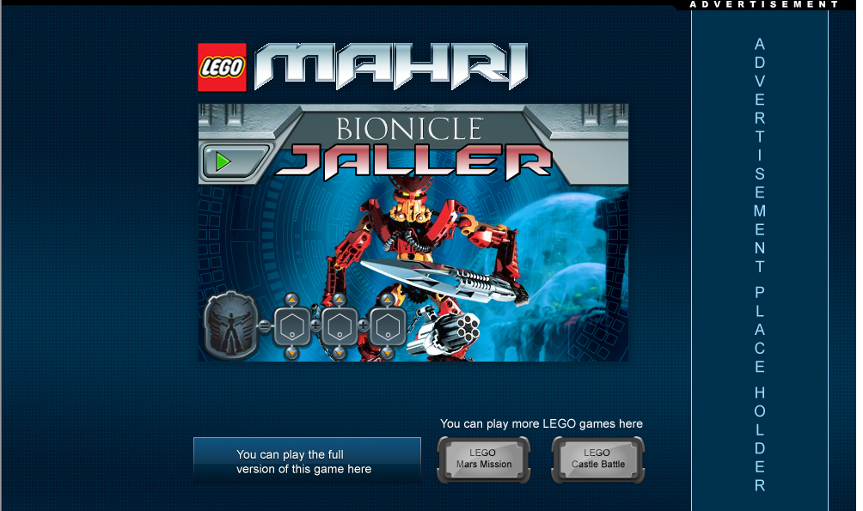
1
2
3
4
1
2
3
4

Please contact me with any questions.

Thanks!

Tony Stewart
3379

