Disney College Program Press Site Test Plan
2/29/2008, Aaron Gidusko

/index.html
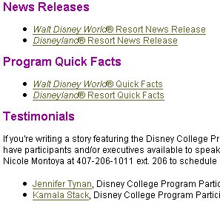
Six body links to MS Word documents

News Releases
Test link: Walt Disney World® Resort News Release
Test link: Disneyland® Resort News Release

Program Quick Facts
Test link: Walt Disney World® Quick Facts
Test link: Disneyland® Resort Quick Facts

Testimonials
Test link: Jennifer Tynan
Test link: Kamala Stack

/images.html
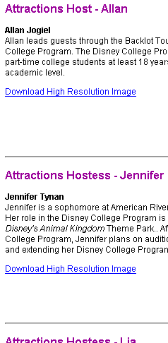
Nine body links to high resolution JPEGS. Text of each link is “Download High Resolution Image”

Test link: Attractions Host - Allan
Test link: Attractions Hostess - Jennifer
Test link: Attractions Hostess - Lia
Test link: Bibbidi Bobbidi Boutique Hostess- Kamala
Test link: Education Presenter- Megan
Test link: Lifeguard- Josh
Test link: Lifeguard- Megan
Test link: Quick Service Restaurants- Sarah (Kingsbury)
Test link: Quick Service Restaurants- Sarah (Kinney)

/video.html
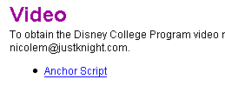
One body link to MS Word document

Test link: Anchor Script

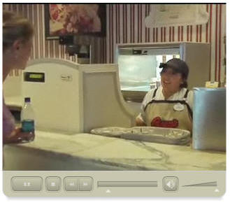
Flash video

Verify Flash content successfully loads
Verify player controls: Play
Verify player controls: Pause
Verify player controls: Stop
Verify player controls: Rewind
Verify player controls: Tracker
Verify player controls: Volume

