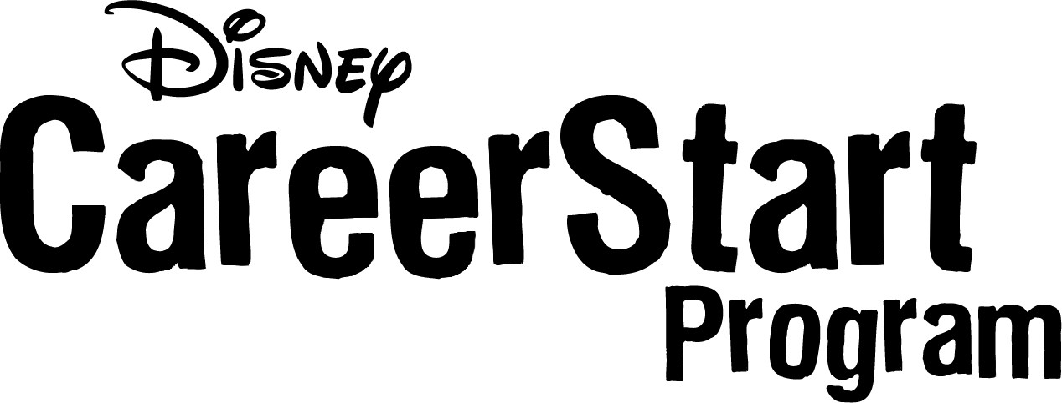
Short Response Form

Name: _____________________________
Address: _____________________________
_____________________________

Please answer the questions below using 3 to 4 sentences:

Why do you want to participate in the Disney CareerStart Program?

What do you expect to gain from participating in the Disney CareerStart Program?

- If you are attending a live presentation:
  - Please bring your completed Application, Role Checklist, and Short Response Form with you to the presentation.
  - Your Letter of Recommendation can be submitted at the presentation as well if available, or it can be mailed in at a later date.

- If you are viewing the E-Presentation:
  - You must fax the Application, Role Checklist, Short Response Form, and Letter of Recommendation to the CareerStart Program Recruiting office at 407-934-6878 before your interview.
  - All forms can also be mailed in to: Disney CareerStart Recruiting, P.O. Box 10090, Lake Buena Vista, FL 32830. If you have any questions, please call 1-800-722-2930.

