Request for QA Testing
 | Disney.com  Back to School - Minisite | Wednesday, July 29, 2026

Submission Information
 |  |  |  | Business Unit: |  | D.COM00
Submission Contact(s): |  | Jason Vriezema | 241.794.6391 | Oracle Billing #: |  | 7004735
Time to go Live: | August 7, 2009 |  |  |  | Time Received by QA:
TS Job#:

Approval for Testing (Please indicated phone number, date, and time)
Integrator: |  | Jason Vriezema |  | Creative/Art Director: |  |  | Samantha Hoey
Producer: |  | Karen Nishimura |  | Legal:
Editorial: |  |  |  | QA Coordinator:

Moved to QA Server (Please note filename(s), initial, and indicate date/time)
Filename(s):

Please Resubmit

Approved to go Live (Please indicate date/time)
QA Analyst: |  |  | QA Coord:

Moved to Staging (Please indicate date/time)
Webmaster:

Checked on Staging (Please indicate date/time)
QA

Moved Live (Please indicate date/time)
Webmaster:

Checked Live (Please indicate date/time)
QA: |  | Work Correctly : Y / N (attach details if N)

URL:
http://disney.go.com/summeratsea/

Landing page
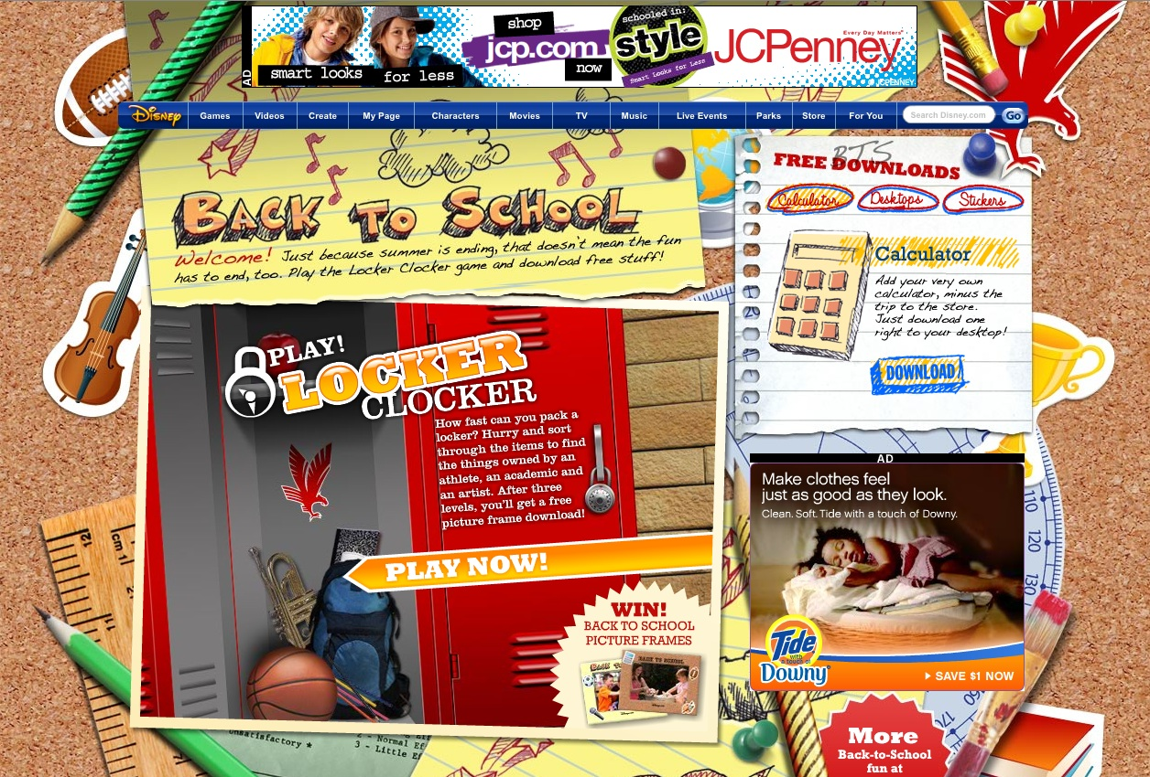

Calculator download page


Wallpaper download page

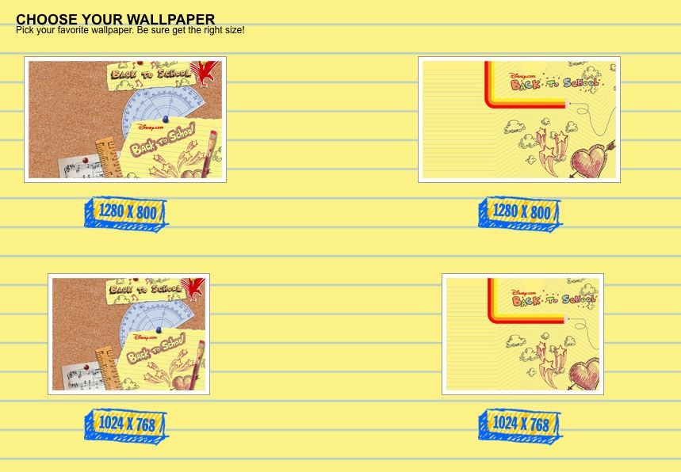

Selected wallpaper download page

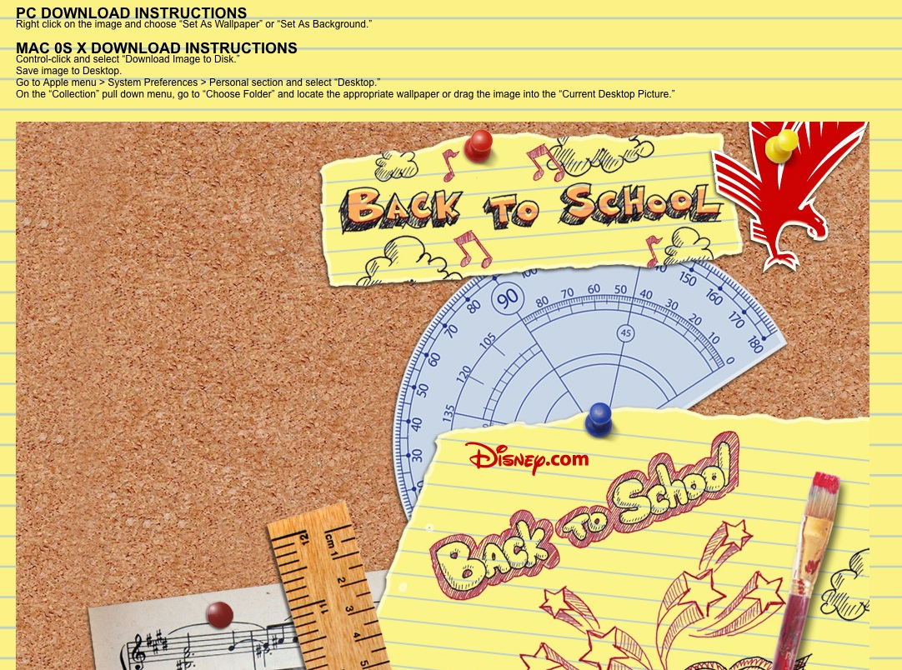

Details

Back to school Marketing site.
Has one game “Locker Clocker”

Has a “tabbed” section for free downloads
Calculator
Desktops
Stickers

1 780x90 Ad
1 320x250
1 234x60 Sponser logo

Please contact me with any questions.

Thanks!

Jason Vriezema
214.794.6391

