Brave Triplets Localization – Standalone/localisable version.

This game has been developed to make localisation a simple and pain free process.

Folder Structure –fig.2

Bin > assets
Bin > languages > markets > images (Title and flag)
Bin > languages > markets > xml (copy and links)
Bin > xml (config and localisation management)

Localizing

The config.xml file (fig.1) determines the languages your game will cater to.
This is managed by simply copying the format and adding a new language using the standard locale ID method (uk/de/es/jp etc).
If a language needs to be added then there is a 3 step process to follow:
Step 1: Create a new locale folder within the ‘languages’ folder. We suggest copying the uk folder, pasting it with a new locale ID.

Step 2: Editing the languages folder internal contents:

Images folder – flag and title treatment
Flag – 148x87 px
TT – 385x160 (transparent png)
XML folder – data.xml
Localise your copy and url links.
Step 3: Editing the master XML (config/languages)
In bin>xml folder you will need to add your new language variant to both the languages.xml first and then the config.xml, in both instances ensuring that you maintain the same locale ID naming convention.
Important:
Please ensure you do not edit the <wisetrack> references.
If you create a standalone game for your own market please change the <country>us<country> variable to suit your market locale ID

Standalone versions– fig.3
Markets have the ability to make a game specific to only their language market and to add or remove the Facebook/high-score integration by means of FLASHVARS found in the index.html.
To limit the game to only your market, removing the language selector, simply uncomment the flashvars.country found in index.html and set it to your locale ID. To open it out to your localisations simply comment this code and the game will refer to your language structure set up as explained above.
<!-- flashvars.country = "uk"; -->

Have fun.

Fig.1 – Config file
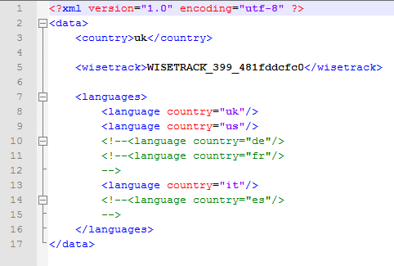

Fig.2 – Folder structure
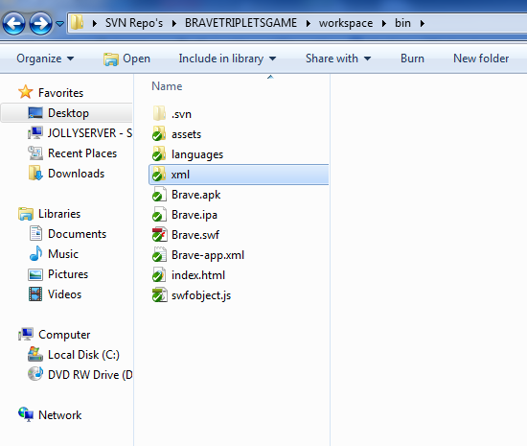

Fig.3 – Flashvars
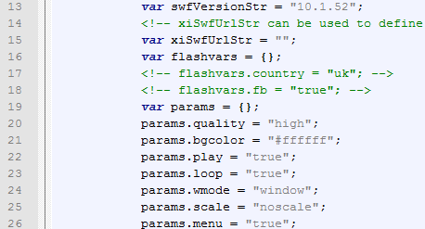

If you have any questions regarding this game or the localisation of this game please contact:
pete@jollywisemedia.co.uk
jon.heffernan@jollywisemedia.co.uk

